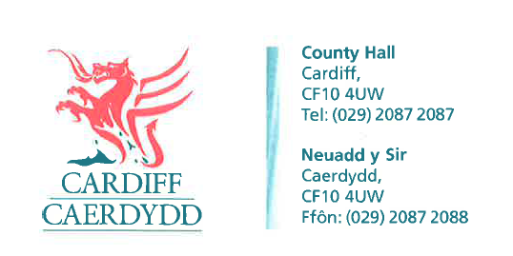
FOI Response Document
FOI18175
Thank you for your request under the Freedom of Information Act 2000 about Contact details received on 25/07/2022.
Request
Can you please advise the names and contact details for the following:
CEO of council
Director of Services
Head of Street Team
Head of Waste
Head of Parks
Head of Highways
Response: Please see FOI18175 - Attachment 1 for the Organisation Structure for Cardiff Council, which shows all Operational Managers and above.
For contact details, In accordance with Section 17 of the Freedom of Information Act 2000 this part of the request acts as a Refusal Notice. The exemption applied is Section 40 (2) Personal Information, FOIA 2000.
This exemption applies because we can only provide information regarding employees above Operational Manager level. Please note that we do not provide the personal contact details of Cardiff Council’s employees. All departments or teams can be contacted via our C2C contact centre team. Please see the below link for further details:
General enquiries (cardiff.gov.uk)
Section 40(2) of the Freedom of Information Act 2000 effectively prohibits the release of personal information if doing so would contravene any of the data protection principles under the Data Protection Act 2018. We have a statutory duty under Section 34 (3) of the Data Protection Act 2018 to comply with the data protection principles.

Leader of council
Response - Huw Thomas. For contact details please see the response above.
The Mayor
Response - Councillor Graham Hinchey. For contact details please see response above.
Member for the environment
Response - The City of Cardiff Council does not hold this information therefore under Section 17 of the Freedom of Information Act 2000 this acts as a refusal notice.
Under Section 16 of the Freedom of Information Act 2000 we have a duty to advise and assist our customers. We don’t currently have a Cabinet Member for environment. Following the Local Government elections in May when the Cabinet was re-established the role of the Cabinet Member for Environment was replaced by a Cabinet Member for Climate Change. These can be found in the link below.
Your Councillors : Cardiff Council (moderngov.co.uk)
If you have any queries or concerns, please do not hesitate to contact us.
Please remember to quote the reference number above in any future communications.

